
Computer

A computer is a machine that can be instructed to carryout sequences of arithmetic or logical operations automatically via computer programming.
OR
A computer is a machine or device that performs processes, calculations and operations based on instructions provided by a software or hardware program.
- It has the ability to accept data (input), process it, and then produce outputs.


Applications of Computer
Home
  - online bill payment
  - watching movies or shows at home
  - home tutoring
  - social media access
  - playing games
  - internet access, etc.
Industry
  - managing inventory
  - designing purpose
  - interior designing
  - video conferencing
  - Online marketing

Medical Field
  - database of patients’ history
  - Diagnosis
  - X-rays
  - live monitoring of patients
  - Surgeons nowadays use robotic surgical devices
Entertainment
  - playing games
  - listening to music
  - MIDI instruments greatly help people in the entertainment industry in recording music with artificial instruments
  - Note: MIDI is an acronym that stands for Musical Instrument Digital Interface. It’s a way to connect devices that make and control sound — such as synthesizers, samplers, and computers — so that they can communicate with each other, using MIDI messages.
  - Photo editors



Education
  - online classes
  - online examinations
  - referring e-books
  - online tutoring
Government
  - computers are used in data processing, maintaining a database of citizens
  - missile development
  - Satellites
  - rocket launches



Banking
  - computers are used to store details of customers
  - conduct transactions-withdrawal and deposit of money through ATMs
Business
  - transaction processing
  - Investments
  - Sales
  - Expenses
  - markets



Training
  - Many organizations use computer-based training to train their employees, to save money and improve performance
Ex-Video conferencing
Science and Engineering
  - Supercomputers have numerous applications in area of Research and Development (R&D).
  - Scientists use computers to plot and analyze data to have a better understanding of earthquakes.



  - Keyboard
Input device
  - Mouse

  - Trackball (computer cursor control device like mouse, the trackball is an upside-down mouse that rotates in place within a socket.)

Output Device
  - Monitor
  - Printer
  - Speaker


Both Input–Output Devices:

  - Modems (it sends data (upload/output) and receives data (download/input)
  - Network cards (The purpose of the network card is to establish a path of communication between the user and the computer. This path works for both sending the data and collecting back the data from the computer)
  - Touch Screen
  - Headsets (Headset consists of Speakers and Microphone.)


Architecture of computer:

Computer system has five basic units that help the computer to perform operations, which are given below:
  - Input Unit
  - Output Unit
  - Storage Unit
  - Arithmetic Logic Unit
  - Control Unit

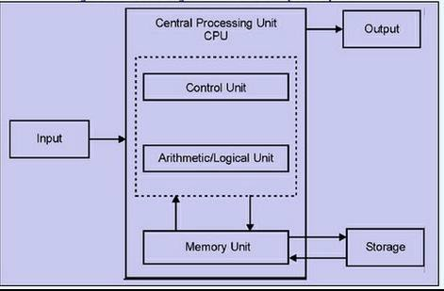



  - The source program/high level language program/coded information/simply data is fed to a computer through input devices keyboard is a most common type.
Input Unit
  - Input unit performs following tasks:
    - Accept the data and instructions from the outside environment.
    - Convert it into machine language.
    - Supply the converted data to computer system.
  - Example
    - Joysticks, trackballs, mouse, scanners etc. are other input devices



  - These actually are the counterparts of input unit.
Output Unit
  - Its basic function is to send the processed results to the outside world.
  - Examples: -
    - Printer, speakers, monitor etc.

Storage Unit
- This unit holds the data and instructions. It also stores the intermediate results before these are sent to the output devices. It also stores the data for later use.
- The storage unit of a computer system can be divided into two categories:
- Primary Storage
- Secondary Storage



  - This memory is used to store the data which is being currently executed. It is used for temporary storage of data.
Primary Storage:
  - The data is lost, when the computer is switched off.
  - RAM is used as primary storage memory.



  - The secondary memory is slower and cheaper than primary memory.
Secondary Storage:
  - It is used for permanent storage of data.
  - Examples: -
    - Magnetic disks & tapes, optical disks (i.e. CD-
ROM’s), floppies etc.,

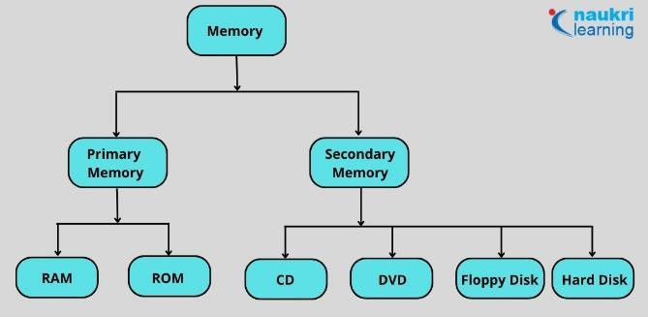



Comparison Parameters | Primary Memory | Secondary Memory
Storage validity | Primary memory is the main memory and stores data temporarily. | Secondary memory is the external memory and stores data permanently.
Access | The CPU can directly access the data. | The CPU cannot directly access the data.
Volatility | Primary memory is volatile. It loses data in case of a power outage. | Secondary memory is non- volatile, and data is stored even during a power failure.
Storage | Data is stored inside costly  semiconductor chips. | Data is stored on external hardware devices like hard drives, floppy disks, etc.
Division | It can be divided into RAM  and ROM | They do not have such a classification. Secondary memories are permanent storage devices like CDs, DVDs, etc.
Speed | Faster | Slower
Stored data | It saves the data that the | It can save various types of data in various formats and

Arithmetic Logical Unit
- All the calculations are performed in ALU of the computer system.
- The ALU can perform basic operations such as addition,
subtraction, division, multiplication etc.
- Whenever calculations are required, the control unit transfers the data from storage unit to ALU. When the operations are done, the result is transferred back to the storage unit.



  - It controls all other units of the computer. It controls the flow of data and instructions to and from the storage unit to ALU.
Control Unit
  - Thus, it is also known as central nervous system of the computer.
  - The main function of a control unit is to fetch the data from the main memory, determine the devices and the operations involved with it, and produce control signals to execute the operations.



CPU (Central Processing Unit)
  - The control unit and ALU are together known as CPU.
  - CPU is the brain of computer system.
  - It performs following tasks:
    - It performs all operations.
    - It takes all decisions.
    - It controls all the units of computer.



Peripherel devices:
  - Peripheral devices are devices that are attached to a computer system.
  - Input devices, output devices, and the various storage units are all peripheral devices. These devices increase the basic services provided by the computer system.
  - Some of the main input devices are discussed here.

- Keyboard
- The keyboard of a computer resembles the keyboard of a
typewriter.
- It consists of
- alphanumeric keys (letters and numbers),
- punctuation keys (comma, colon, semicolon, etc.),
- special keys (control keys, arrow keys, function keys, etc.).
- These keys are placed in the ‘Q-W-E-R-T-Y' layout, similar to
those in a typewriter.
- When a key is pressed, electronic signals are generated. A keyboard encoder(also called keyboard controller) detects these signals and sends them to the CPU.
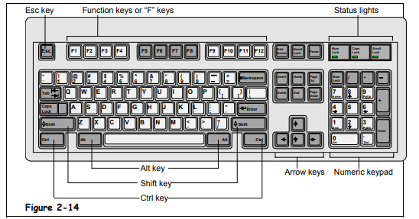
- The most popular keyboard is the one with 101 keys.

Mouse
- The mouse is a handheld pointing device that controls the movement of the cursor or pointer on the monitor or the display screen.
- It is connected to the computer system through a cable. A mouse has one to four buttons (usually two or three) and can be used for clicking on an icon, selecting a text or an object, dragging the selected items, etc.

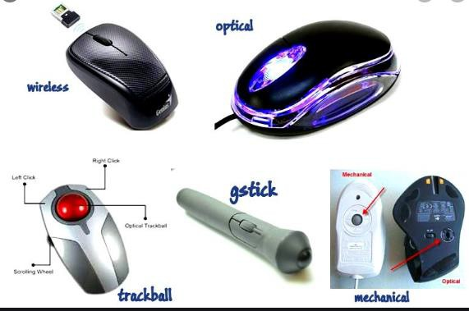




Touchpad
  - In most of the laptop computers, the mouse is replaced by a touchpad.
  - A touchpad is a very small, touch sensitive device that is placed in front of the keyboard.
  - The movement of a finger placed on the touchpad moves the cursor on the screen.

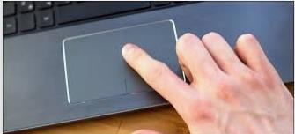


Joystick

  - A joystick is a controlling device which is most often used for playing computer games or controlling robots in the manufacturing industry.
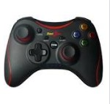
  - It has a gearshift like lever which is used to move the pointer or cursor on the screen. Generally, joysticks are two dimensional with two sides of movement.




Trackball
  - trackball is a computer pointing device which can perform the same functions as a mouse.
  - Computer mice have small balls inside of them, and when a user moves the mouse, the ball rolls, causing the pointer on the screen to move. With a trackball, the user simply rolls the ball itself using her fingers or thumb, while the body of the device stays in place.

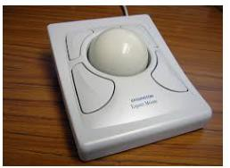

Difference Between Mouse and Trackball
 | Mouse | Trackball
1. | The mouse has to be moved when  used. | The track ball Is stationary.
2. | A mouse consists of a metal or plastic housing or caring, a ball at its base and is rolled on a flat horizontal surface. | You use a trackball by the rolling the ball with your palm and fingers.
3. | It is popular among regular users. | It is mainly used for industrial purposes.
4. | Mouse is commonly use.  It is less expensive compared to the  trackball. | Trackball is rear use.  It is an expensive input device.



Light pen

  - Light pens are pointing devices that resemble pens and are connected to the visual display unit.
  - Basically light pen used with cathode ray tube monitor.
  - These devices are used for selecting menu items or for drawing pictures.
  - A light pen consists of a small tube that contains a photocell and an optical system. When the tip of the pen touches the screen, the photocell sends the corresponding signal to the CPU indicating the screen location.

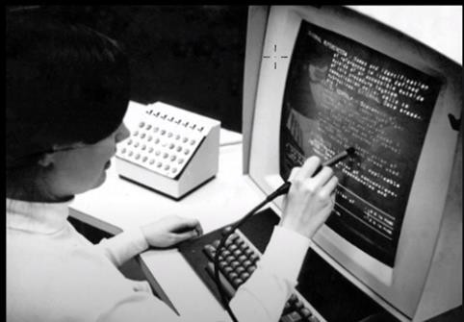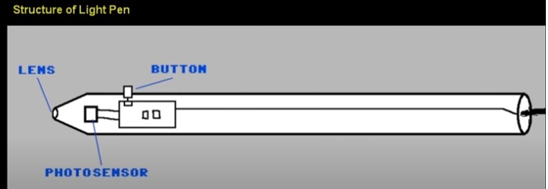Light pen


Touch screens

  - A touch screen is used in place of a keyboard. Touch screens recognize the human touch. Using them, users can point to the selection on the screen using their fingers.
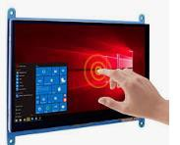


Scanners

  - Scanners are devices that are designed to copy anything that is printed on a sheet of paper.
  - They have the ability to analyze a picture or text and then convert it into a digital image.
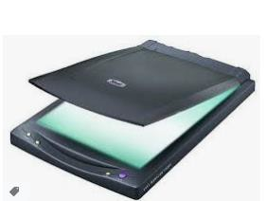



- Computer output devices receive information from the computer,
Output Devices
and carry data that has been processed by the computer to the user.
Examples of Output Devices:-
- Monitor –
This is the most common computer output device. It creates a visual display by the use of which users can view processed data. Monitors come in various sizes and resolutions.
Common Types of Monitors
  - CRT stands for Cathode Ray Tube. CRT is a technology used in traditional computer monitors and televisions. The image on CRT display is created by firing electrons from the back of the tube of phosphorus located towards the front of the screen.
  - Once the electron heats the phosphorus, they light up, and they are projected on a screen. The color you view on the screen is produced by a blend of red, blue and green light.



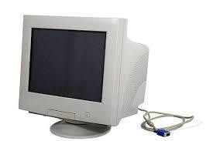

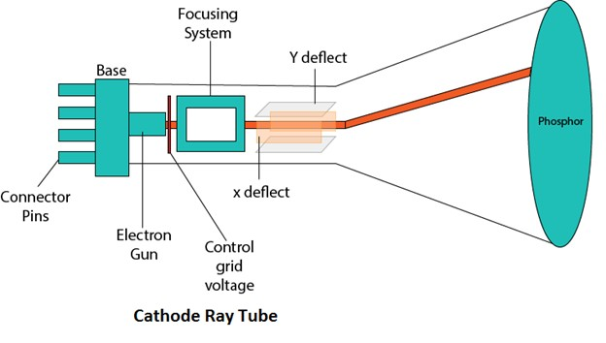



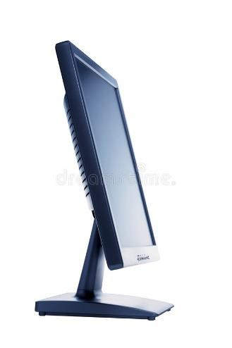
Flat Panel Screen – this makes use of liquid crystals or plasma to produce output. Light is passed through the liquid crystals in order to generate pixels.




Printer
    - This device generates a hard copy version of processed data, like documents and photographs. The computer transmits the image data to the printer, which then physically recreates the image, typically on paper.
Types of Printers
    - Ink Jet – this kind of printer sprays tiny dots of ink onto a paper to form an image. Cheaper but need to take print out frequently otherwise cartridge will dry and then changing cartridge frequently is costly.
    - The ink in the cartridges of these printers is in liquid form. They have nozzles from which ink is sprayed onto paper and it gets printed.
    - The disadvantage of this type of printer is that if you do not use it for a long time, then the ink in the cartridges gets dry. Then you have to clean it to use it again.
    - Example –
HP Deskjet 1112 printer, Epson L130 single function printer, Epson L361 printer.




Printer
    - Laser - One of the big advantages of laser printers is
that they don’t require ink.
    - Instead, laser printers use toner cartridges.
    - Toner is a very fine, dry powdered substance, which comes in cylindrical cartridges.
    - When a laser printer produces a document, it’s actually
toner on the surface of the final printed page.
    - First, the laser printer reads the electronic data that makes up the information or image that you want to print and beams this onto a photo-sensitive drum.
    - The information on the drum is then transferred to paper using static electricity to position tiny particles of powdered toner in the correct pattern.




Printer
    - The toner powder is then permanently fused onto the paper by the heat and pressure from rollers inside the machine and your finished printout is ready.
    - They are more reliable in comparison to inkjet printers.
    - They don’t use nozzle and its ink is in the form of powder which is to be put in the given bar, that is why ink of these types of printers don’t dry up whether you use these once a year or you don’t use it at all.
    - Examples: HP Color LaserJet Pro MFP M479fdw
    - Canon MF232W



    - Dot Matrix – Dot matrix printing uses a print head that moves back-and- forth, or in an up-and-down motion, on the page and prints by impact, striking an ink-soaked cloth ribbon against the paper, much like the print mechanism on a typewriter.
Printer
    - It is used in printing passbook, railway tickets, mark sheets etc.

Speakers
    - speakers are attached to computers to facilitate the output of sound; sound cards are required in the computer for speakers to function.
    - The different kinds of speakers range from simple, two-speaker output devices right the way up to surround-sound multi- channel units.

    - There are some important CPU specifications and terms. Each term is important to understand and know when choosing a processor.
      - Multi-Core Technology
      - CPU Sockets and Chipsets
      - Frequency (Clock Rate)
      - Hyperthreading
      - Cache
      - Thermal Design Power (TDP)



Multi-core technology
- A multicore processor is an integrated circuit that has two or more processor cores attached for enhanced performance and reduced power consumption.
- These processors also enable more efficient simultaneous processing of multiple tasks, such as with parallel processing and multithreading.
- By doing so, a multi-core CPU is allowed to do two things at once, rather than having to process one thing at a time. This significantly increases a processor’s performance.
- A processor is like a computer's brain - and Intel® Core™ processors are the most powerful. They have multiple cores for more power and smoother multi-tasking. There are 4 main categories: i3, i5, i7 and i9. Each has numerous spec options, but strictly speaking i5 is superior to i3 and so on.



CPU Sockets and Chipsets
- As processing technology advances, the two main CPU manufacturers (Intel and AMD) continually come out with new series of CPUs.
- Along with different series of processors, there are also different sockets. The CPU socket is where the processor will be installed on the motherboard.
- CPU socket is also called processor socket. Within CPU socket processor is installed and with the help of that socket, processor can communicate with other parts like hard disk, RAM etc.
- When we connect wire to plug and it gets electricity and then it works same way when we connect CPU or processor with CPU socket (available on motherboard), processor is connected with all other parts available on motherboard.

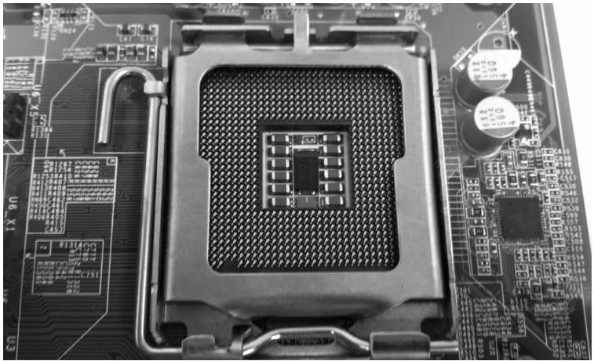



- There are 3 types of sockets.
- PGA- pin grad array (it uses small pins as connections; pins are available on CPU and holes are available on sockets)
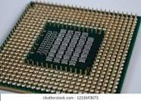

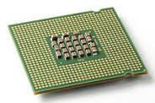
- LGA- land grid array (pins are available on sockets and CPU has some contact points as shown below.)
- Intel is using LGA.

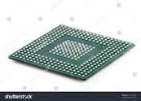
- BGA – ball grid array (balls are available on CPU and some spaces are available on socket to fit that CPU on socket, and CPU is permanently fixed with soldering on socket.)


- For instance, Intel’s Core series of CPUs have gone through many sockets, including LGA 775, LGA 1156, LGA 1155, LGA
1150, and most recently, LGA 1151.
- Example:
If you decide to buy an Intel Core i7 920 CPU, which is based on the LGA 1366, you have to buy a motherboard with a LGA 1366 socket for your cpu and motherboard to be compatible.


Operating Frequency (GHz)

  - CPU operating frequency, or clock rate, (which is measured in hertz).
  - The operating frequency of a processor is how fast it can complete a single cycle of work. The higher the frequency, the faster it can complete a single cycle of work.
  - A CPU with a clock speed of 3.2 GHz executes 3.2 billion cycles per second.
  - 3.5 to 4.2 GHz is a good speed for processor.

Hyperthreading
- Basically, hyperthreading allows the CPU to work on two different threads (sequences of instructions for the CPU to carry out) at the same time.
- It allows the processor to work on two different things simultaneously.
- It increases CPU performance by improving the processor’s efficiency, thereby allowing you to run multiple demanding apps at the same time or use heavily-threaded apps without the PC lagging.
- Hyper-threading is currently available on Intel Core, Core vPro, Core M and Xeon processors.


Cache

  - Cache is on-board memory for your
processor. It’s like RAM, but it offers even quicker access, since it’s located directly on your processor. While it only presents a small fraction of storage space as compared to your RAM and your hard drive, it is extremely fast and is used for the most important data relative to the tasks you are carrying out on your computer.
  - So, the more cache your processor has, the better overall it will perform.


Thermal Design Power

  - This is a general measurement that indicates how much power, in Watts, that your processor will consume in the worst-case scenario. This is also used to have an idea of how much heat your processor will produce.
  - Same here, a lower number is desirable, to lower your electricity bill.
  - A processor which consumes more power and emits more heat will also need a better heatsink, or a faster fan, which usually results in a noisier computer.
  - The lower the TDP of a processor, the less cooling it will need in order to operate at acceptable temperature levels.
  - The higher the TDP of a CPU and the more cooling you will
need.




Storage Devices
- A storage unit is a part of the computer system which is employed to store the information and instructions to be processed.
- A storage device is an integral part of the computer hardware which stores information/data to process the result of any computational work. Without a storage device, a computer would not be able to run or even boot up. Or in other words, we can say that a storage device is hardware that is used for storing data files. It can also store information/data both temporarily and permanently.
- Computer storage is of two types:
- Primary Storage Devices: It is also known as internal memory and main memory. This is a section of the CPU that holds program instructions, input data, and intermediate results. It is generally smaller in size. RAM (Random Access Memory – volatile) and ROM (Read Only Memory – nonvolatile) are examples of primary storage.
- Secondary Storage Devices: Secondary storage is a memory that is stored external to the computer. It is mainly used for the permanent and long-term storage of programs and data. Hard Disk, CD, DVD, Pen/Flash drive, SSD, etc., are examples of secondary storage.




Primary Storage Device
  - RAM: It stands for Random Access Memory. It is used to store information that is used immediately or we can say that it is a temporary memory.
  - Computers bring the software installed on a hard disk to RAM to process it and to be used by the user. Once, the computer is turned off, the data is deleted.
  - With the help of RAM, computers can perform multiple tasks like loading applications, browsing the web, editing a spreadsheet, experiencing the newest game, etc.
  - It allows you to modify quickly among these tasks, remembering where you’re in one task once you switch to a different task. It is also used to load and run applications, like your spreadsheet program, answer commands, like all edits you made within the spreadsheet, or toggle between multiple programs, like once you left the spreadsheet to see the email.
  - Memory is nearly always being actively employed by your computer. It ranges from 1GB – 32GB/64GB depending upon the specifications. There are different types of RAM, although they all serve the same purpose, the most common ones are:




Primary Storage Device
  - SRAM: It stands for Static Random Access Memory. It consists of circuits that retain stored information as long as the power is supply is on. It is also known as volatile memory.
  - It is used to build Cache memory. Acts as cache; storage measured in MBs
  - It is much faster as compared to DRAM but in terms of cost, it is costly as compared to DRAM.
  - DRAM: It stands for Dynamic Random Access Memory.
  - Connects directly to CPU bus, volatile storage measured in GBs
  - The access time of DRAM is slower as compare to SRAM and it is cheaper than SRAM
  - SDRAM: It stands for Synchronous Dynamic Random Access Memory. It is faster than DRAM. It is widely used in computers and others. After SDRAM was introduced, the upgraded version of double data rate RAM, i.e., DDR1, DDR2, DDR3, and DDR4 was entered into the market and widely used in home/office desktops and laptops.




Primary Storage Device
  - ROM: It stands for Read-Only Memory.
  - The data written or stored in these devices are non-volatile, i.e., once the
data is stored in the memory cannot be modified or deleted.
  - The memory from which will only read but cannot write it. This type of memory is non-volatile. The information is stored permanently during manufacture only once.
  - ROM stores instructions that are used to start a computer. This operation is referred to as bootstrap.
  - It is also used in other electronic items like washers and microwaves. ROM chips can only store few megabytes (MB) of data, which ranges between 4 and 8 MB per ROM chip. There are two types of ROM:
  - PROM: PROM is Programmable Read-Only Memory. These are ROMs that can be programmed. A special PROM programmer is employed to enter the program on the PROM. Once the chip has been programmed,
information on the PROM can’t be altered. PROM is non-volatile, that is
data is not lost when power is switched off.
  - EPROM: Another sort of memory is that the Erasable Programmable Read-Only Memory. It is possible to erase the info which has been previously stored on an EPROM and write new data onto the chip.


Examples of Storage Device

  - Magnetic Storage Device – one of the most popular types of storage used.
    - Floppy diskette – It is also known as a floppy diskette. It is generally used on a personal computer to store data externally. A Floppy disk is made up of a plastic cartridge and secures with a protective case.
    - A normal 3 ½ inch disk can store 1.44 MB of data.
    - Hard drive – An internal hard drive is the main storage device in a computer. An external hard drive is also known as removable hard drive. It is used to store portable data and backups. It ranges from a few GBs to a few and more TB.
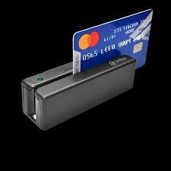
    - Magnetic card – It is a card in which data is stored by modifying or rearranging the magnetism of tiny iron-based magnetic particles present on the band of the card. It is also known as a swipe card. It is used like a passcode (to enter into house or hotel room), credit card, identity card, etc.

Optical Storage Device – uses lasers and lights as its mode of saving and retrieving data.
- Blu-ray disc – It is just like CD and DVD but the storage capacity of blue ray is up to 25GB.To run a Blu-ray disc you need a separate Blu-ray reader.
- CD disc – It is known as Compact Disc. It contains tracks and sectors on its surface to store data. It is made up of polycarbonate plastic and is circular in shape. CD can store data up to 700MB. It is of two types:
- CD-R: It stands for Compact Disc read-only. In this type of CD, once the
data is written cannot be erased. It is read-only.
- CD-RW: It stands for Compact Disc read Write. In this type of CD, you can easily write or erase data multiple times.
- DVD: It is known as Digital Versatile Disc. DVDs are circular flat optical discs used to store data. It comes in two different sizes one is 4.7GB single- layer discs and another one is 8.5GB double-layer discs. DVDs look like CDs but the storage capacity of DVDs is more than as compared to CDs. It is of two types:
- DVD-R: It stands for Digital Versatile Disc read-only. In this type of DVD, once the data is written cannot be erased. It is read-only. It is generally used to write movies, etc.
- DVD-RW: It stands for Digital Versatile Disc read Write. In this type of DVD, you can easily write or erase data multiple times.

Flash Memory Device –It is the most commonly used device to store data because is more reliable and efficient as compare to other storage devices.
SSD – Solid State Drive – It stands for Solid State Drive, a mass storage device like HDDs. It is more durable because it does not contain optical disks inside like hard disks. It needs less power as compared to hard disks, is lightweight, and has 10x faster read and write speed as compared to hard disks. But these are costly as well.
- Pen Drive: It is also known as a USB flash drive that includes flash memory with an integrated USB interface. We can directly connect these devices to our computers and laptops and read/write data into them in a much faster and efficient way. These devices are very portable. It ranges from 1GB to 256GB generally.

Flash Memory Device –
Multimedia Card: It is also known as MMC. It is an integrated circuit that is generally used in-car radios, digital cameras, etc. It is an external device to store data/information. Storage is up to 32 MB.
- Memory Card: A memory card is a type of storage device that is used for storing media and data files.
- It provides a permanent and non-volatile medium to store data and files from the attached device.
- Memory cards are commonly used in small, portable devices, such as cameras and phones.
It is also used to store large amounts of data and is available in different sizes. To run a memory card on a computer you require a separate memory card reader.
An electronic flash memory device used to store digital information and commonly used in mobile electronic devices.

  - Online and Cloud: Data is managed remotely and made available over a network. Basic features are free to use but upgraded version is paid monthly as a per consumption rate. Unlike a USB drive, external hard drive, or flash drive, users do not need to carry around a physical device to store their data. They just have to remember a password and access the data anywhere.
  - Online storage is a viable option for data backup: it provides both security and convenience to the end user

    - Paper Storage – method used by early computers for saving information.
      - OMR – stands for Optical Mark Recognition A process of capturing marked data of human from forms like surveys and tests. It is used to read questionnaires with multiple choices that are shaded.
    - Punch card – Punch cards (or "punched cards"), also known as Hollerith cards or IBM cards, are paper cards where holes may be punched by hand or machine to represent computer data and instructions.
    - They were a widely-used means of inputting data into early computers. The cards were fed into a card reader connected to a computer, which converted the sequence of holes
to digital information.

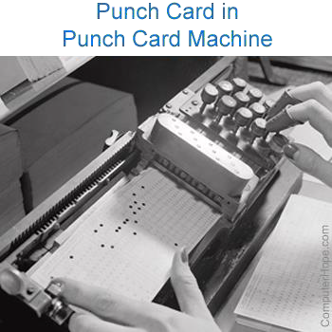
    - For example, an early computer programmer would write a program by hand, then convert the program to several punched cards using a punch card machine. The programmer would then take the stack of cards to a computer and feed the cards into a card reader to input the program. Picture is an example of a woman using a punch card machine to create a punch card.



    - Booting is basically the process of starting the computer.
Booting
    - When the CPU is first switched on it has nothing inside the Memory.
    - In order to start the computer, load the Operating System into the Main Memory and then Computer is ready to take commands from the User.

What happens in the Process of Booting?
    - Booting happens when you start the computer. This happens when we turned ON the power or the computer restarts. The system BIOS (Basic Input/Output System) makes the peripheral devices active. Further, it requires that the boot device loads the operating system into the main memory.
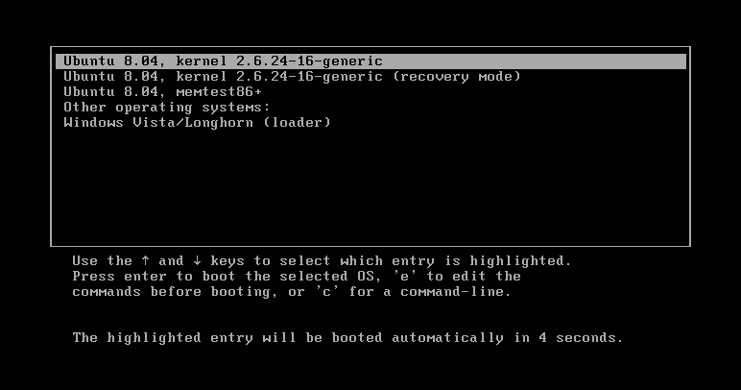

BIOS
    - A computer's BIOS (basic input/output – typically stored on EPROM) is its motherboard firmware (Firmware is a type of software that is fixed directly into a piece of hardware.), the software which runs at a lower level than the operating system and tells the computer what drive to boot from RAM you have and controls other key details like CPU frequency. You can go into the BIOS menu to change your boot order.
    - In order to access BIOS on a Windows PC, you must press your BIOS key set by your manufacturer which could be F10, F2, F12, F1, or DEL.
    - If your PC goes through its power on self-test startup too quickly, you can also enter BIOS through Windows 10’s advanced start menu recovery settings.

Boot Devices
    - Booting can be done either through hardware (pressing the start button) or by giving software commands.
    - Therefore, a boot device is a device that loads the operating system.
    - Moreover, it contains the instructions and files which start the computer.
    - Examples are the hard drive, floppy disk drive, CD drive, etc. Among them, the hard drive is the most used one.


Types of Booting
- There are two types of booting:
    - Cold Booting
    - A cold boot is also called a hard boot. It is the process when we first start the computer.
    - In other words, when the computer is started from its initial state by pressing the power button it is called cold boot.
    - The instructions are read from the ROM and the operating system
is loaded in the main memory.
    - Warm Booting
    - Warm Boot is also called soft boot.
    - It refers to when we restart the computer.
    - Here, the computer does not start from the initial state.
    - When the system gets stuck sometimes it is required to restart it
while it is ON.
    - Therefore, in this condition the warm boot takes place. Restart button or CTRL+ALT+DELETE keys are used for warm boot.

Steps of Booting
    - We can describe the boot process in six steps:
    - 1.The Startup
    - It is the first step that involves switching the power ON. It supplies electricity to the main components like BIOS and processor.
    - 2. BIOS: Power on Self-Test
    - It is an initial test performed by the BIOS.
    - Further, this test performs an initial check on the input/output
devices, computer’s main memory, disk drives, etc. Moreover, if any
error occurs; the system produces a beep sound.
    - 3. Loading of OS
    - In this step, the operating system is loaded into the main memory. The operating system starts working and executes all the initial files and instructions.

Steps of Booting

4. System Configuration
    - In this step, the drivers are loaded into the main memory. Drivers are programs that help in the functioning of the peripheral devices.

5. Loading System Utilities
    - System utilities are basic functioning programs, for example, volume control, antivirus, etc. In this step, system utilities are loaded into the memory.

6. User Authentication
    - If any password has been set up in the computer system, the system checks for user authentication. Once the user enters the login Id and password correctly the system finally starts.




Computer Name
    - A computer name is a unique identifier that is given to each computer and is used to locate and connect to a computer in order to perform routine maintenance, as well as provide remote technical assistance.
    - Computer names are also required for those employees who wish to remote into their office machine from another location; such as from home.
    - All computer names are set up in a standard format that contains location and identifying information. You can locate the computer name of a PC by completing the following steps:



    - On the desktop, right-click the computer icon and
Computer Name
select Properties from the menu that appears.
    - In the dialog box that appears, the full computer name can be located in
the Computer Name, Domain, and Workgroup Settings section.
    - Or open command prompt and then type hostname command it will also display computer name.



    - A workgroup is a peer-to-peer network using Microsoft software. A workgroup allows all participating and connected systems to access shared resources such as files, system resources and printers.
Workgroup



What is the difference between a domain and a workgroup?
    - Computers on a network can be part of a workgroup or a domain. The main difference between workgroups and domains is how resources on the network are managed. Computers on home networks are usually part of a workgroup, and computers on workplace networks are usually part of a domain.
    - In a workgroup:
    - All computers are peers; no computer has control over another computer.
    - Each computer has a set of user accounts. To use any computer in the workgroup, you must have an account on that computer.
    - All computers must be on the same local network.
    - In a domain:
    - One or more computers are servers. Network administrators use servers to control the security and permissions for all computers on the domain. This makes it easy to make changes because the changes are automatically made to all computers.
    - If you have a user account on the domain, you can log on to any computer on
the domain without needing an account on that computer.
    - There can be hundreds or thousands of computers.
    - The computers can be on different local networks.
    - Due to the increase security and manageability in a domain environment it is always recommended to implement a domain environment for our clients




IP
    - An IP address is a unique address that identifies a device on the internet or a local network. IP stands for "Internet Protocol," which is the set of rules governing the format of data sent via the internet or local network.
    - In essence, IP addresses are the identifier that allows information to be sent between devices on a network: they contain location information and make devices accessible for communication. The internet needs a way to differentiate between different computers, routers, and websites.
    - An IP address is a string of numbers separated by periods. IP addresses are expressed as a set of four numbers — an example address might be 192.158.1.38. Each number in the set can range from 0 to 255. So, the full IP addressing range goes from
0.0.0.0 to 255.255.255.255.




Find IP Address

First, click on your Start Menu and type cmd in the search box and press enter.
    - Type ipconfig /all and press enter. There is a space between the command ipconfig and the switch of /all. Your ip address will be the IPv4 address.
    - Another way to find IP address is, type network and sharing center in run, click local area connection, then click details, IPv4 is your IP address.



    - The Domain Name System (DNS) is the phonebook of the Internet. Humans access information online through domain names, like nytimes.com or espn.com. Web browsers interact through Internet Protocol (IP) addresses. DNS translates domain names to IP addresses so browsers can load Internet resources.
DNS
    - Each device connected to the Internet has a unique IP address which other machines use to find the device. DNS servers eliminate the need for humans to memorize IP addresses such as 192.168.1.1

How DNS works
    - DNS servers convert URLs and domain names into IP addresses that computers can understand and use.
    - They translate what a user types into a browser into something the machine can use to find a webpage. This process of translation and lookup is called DNS resolution.

How DNS works
    - The basic process of a DNS resolution follows these steps:
- The user enters a web address or domain name into a browser.
- The browser sends a message, called a recursive DNS query, to the network to find out which IP or network address the domain corresponds to.
- The query goes to a recursive DNS server, which is also called a recursive resolver, and is usually managed by the internet service provider (ISP). If the recursive resolver has the address, it will return the address to the user, and the webpage will load.
- If the recursive DNS server does not have an answer, it will query a series of other servers in the following order: DNS root name servers, top-level domain (TLD) name servers and authoritative name servers.

How DNS works
- The three server types work together and continue redirecting until they retrieve a DNS record that contains the queried IP address. It sends this information to the recursive DNS server, and the webpage the user is looking for loads. DNS root name servers and top-level domain (TLD) servers primarily redirect queries and rarely provide the resolution themselves.
- The recursive server stores, or caches, the record for the domain name, which contains the IP address. The next time it receives a request for that domain name, it can respond directly to the user instead of querying other servers.
- If the query reaches the authoritative server and it cannot find the information, it returns an error message.



  - Proxy servers work by facilitating web requests and responses between a user and web server.
Proxy server
  - Typically, a user accesses a website by sending a direct request to its web server from a web browser via their IP address. The web server then sends a response containing the website data directly back to the user.


Proxy server
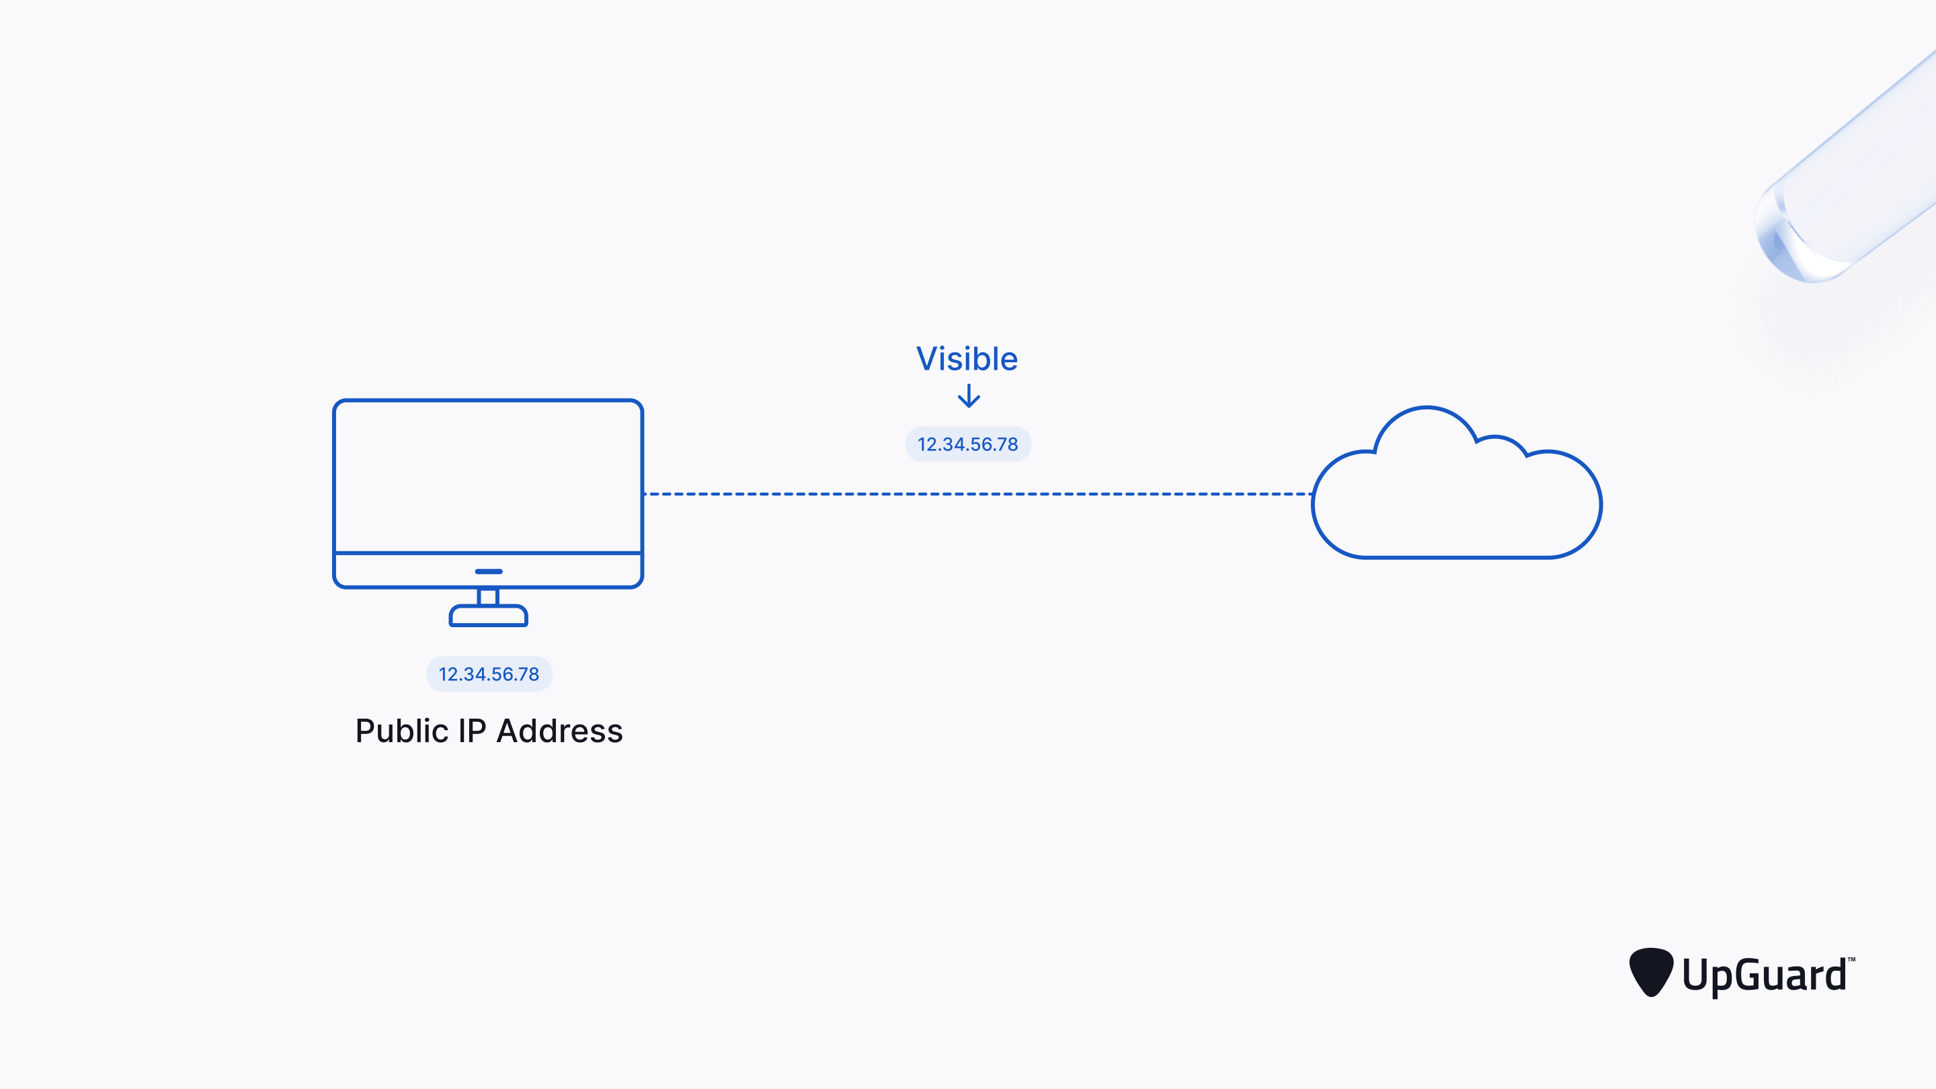




Proxy server
  - A proxy server acts as an intermediary between the user and the web server. Proxy servers use a different IP address on behalf of the user, concealing the user's real address from web servers.

  - A standard proxy server configuration works as follows:

  - A user enters a website's URL into their browser.
  - The proxy server receives the user's request.
  - The proxy server forwards the request to the web server.
  - The web server sends a response (website data) back to the proxy server.
  - The proxy server forwards the response to the user.

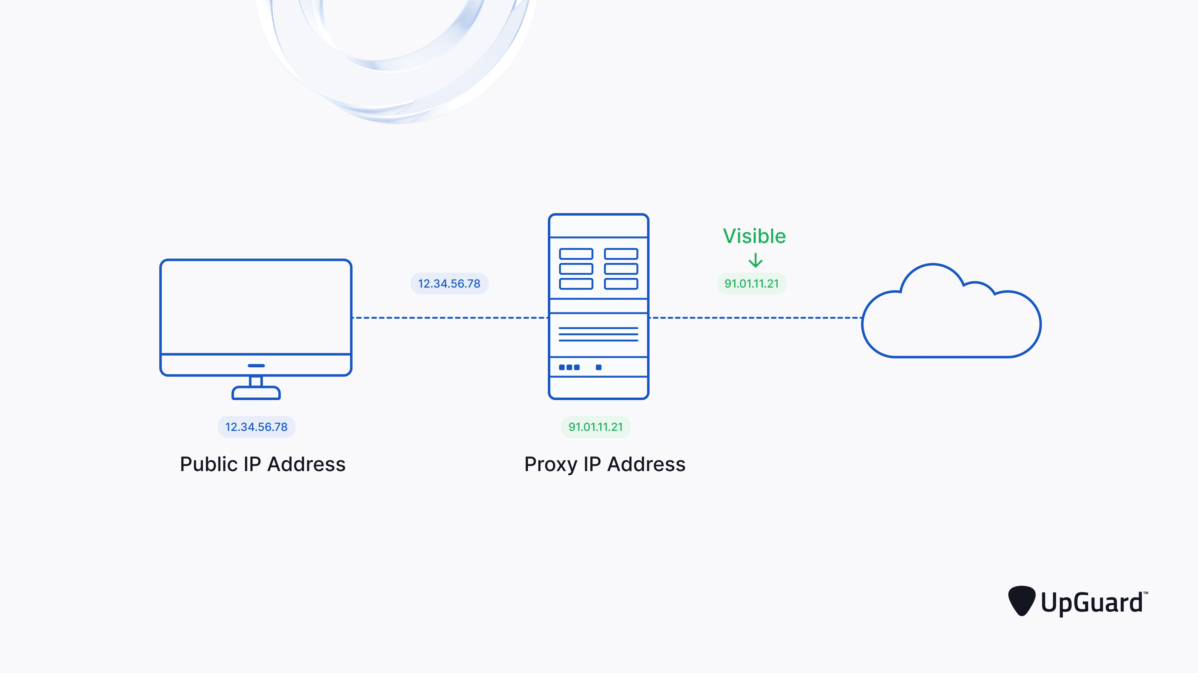

Proxy server


Mechanism of Proxy Server
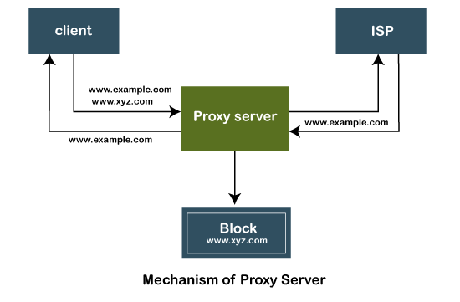

Mechanism of Proxy Server
  - The proxy server accepts the request from the client and produces a response based on the following conditions:
  - If the requested data or page already exists in the local cache, the proxy server itself provides the required retrieval to the client.
  - If the requested data or page does not exist in the local cache, the proxy server forwards that request to the destination server.
  - The proxy servers transfer the replies to the client and also being cached to them.
  - Therefore, it can be said that the proxy server acts as a client as well as the server.

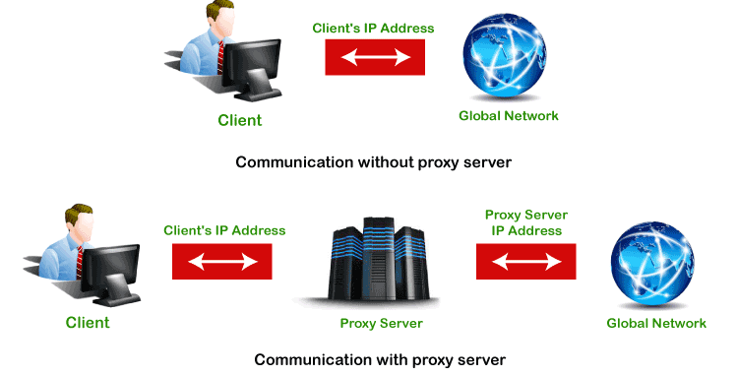
Mechanism of Proxy Server


Password

  - Start > Control Panel or Start > Settings
> Control Panel.
  - Click on User Accounts. Then click change your windows password. Enter your current Windows password, then enter the new password and confirm it.
  - Click Change your password in the User Account Window.



  - A user account allows you to sign in to your computer.
Users
  - By default, your computer already has one user account, which you were required to create when you set up your computer.
  - If you plan to share your computer with others, you can create a separate user account for each person.

Why use separate user accounts?

  - At this point, you may be wondering why you would even need to use separate user accounts.
  - But if you're sharing a computer with multiple people—for example, with your family or at the office—user accounts allow everyone to save their own files, preferences, and settings without affecting other computer users.
  - When you start your computer, you'll be able to choose which account you want to use.



  - Select the Windows Start menu button.
Users
  - Select Control Panel.
  - Select User Accounts.
  - Select Manage another account.
  - Select Create a new account.
  - In the New Account Name text box, type a name for the new account.
  - Click Create Account.



  - Troubleshooting is the process of identifying and solving technical problems. It starts with general issues and then gets more specific.
Basic troubleshooting of a computer system

  - Problem: An application is running slowly
Solution 1: Close and reopen the application.
Solution 2: Update the application.

- Problem: An application is frozen
Sometimes an application may become stuck,
or frozen. When this happens, you won't be able to close the window or click any buttons within the application.
- Solution 1: Force quit the application. On a PC, you can press Alt+f4
- Solution II:Ctrl+Alt+Delete (the Control, Alt, and Delete keys) on your keyboard to open
the Task Manager. On a Mac, press and hold Command+Option+Esc. You can then
select the unresponsive application and click End task (or Force Quit on a Mac) to close it.

  - Problem: All programs on the computer run slowly
  - Solution 1: Run a virus scanner.
  - Solution 2: Your computer may be running out of hard drive space. Try deleting any files or programs you don't need.
  - Solution 3: You can run Disk Defragmenter

    - Problem: The mouse or keyboard has stopped working
    - Solution 1: If you're using a wired mouse or keyboard, make sure it's correctly plugged into the computer.
    - Solution 2: If you're using
a wireless mouse or keyboard, make sure it's turned on and that its batteries are charged.

Problem: If Audio is not working properly
- Solution 1: Check the volume level. Click the audio button in the top-right or bottom-right corner of the screen to make sure the sound is turned on and that the volume is up.
- Solution 2: Check the audio player controls. Many audio and video players will have their own separate audio controls. Make sure the sound is turned on and that the volume is turned up in the player.
- Solution 3: Check the cables. Make sure external speakers are plugged in, turned on, and connected to the correct audio port or a USB port. If your computer
has color-coded ports, the audio output port will usually be green.
- Solution 4: Connect headphones to the computer to find out if you can hear sound through the headphones.

Problem: The screen is blank
  - Solution 1: The computer may be
in Sleep mode. Click the mouse or press any key on the keyboard to wake it.
  - Solution 2: Make sure the monitor is plugged in and turned on.
  - Solution 3: Make sure the computer is plugged in and turned on.
  - Solution 4: If you're using a desktop, make sure the monitor cable is properly connected to the computer tower and the monitor.

- Slow Internet
To improve your Internet browser performance, you need to clear cookies and Internet temporary files frequently. In the Windows search bar, type ‘%temp%’ and hit enter to open the temporary files folder. Clearing the Temp folder is a standard procedure for system administration to reduce the amount of storage space used.
- Overheating
If a computer case lacks a sufficient cooling system, then the computer’s components may start to generate excess heat during operation. To avoid your computer burning itself out, turn it off and let it rest if it’s getting hot. Additionally, you can check the fan to make sure it’s working properly.
- Dropped Internet Connections
Dropped Internet connections can be very frustrating. Often the problem is simple and may be caused by a bad cable or phone line, which is easy to fix. More serious problems include viruses, a bad network card or modem, or a problem with the driver.



  - Uninstall unnecessary software
Optimizing the computer performance
If you don’t need any software then uninstall it. Go to
control panel -> programs -> uninstall a program
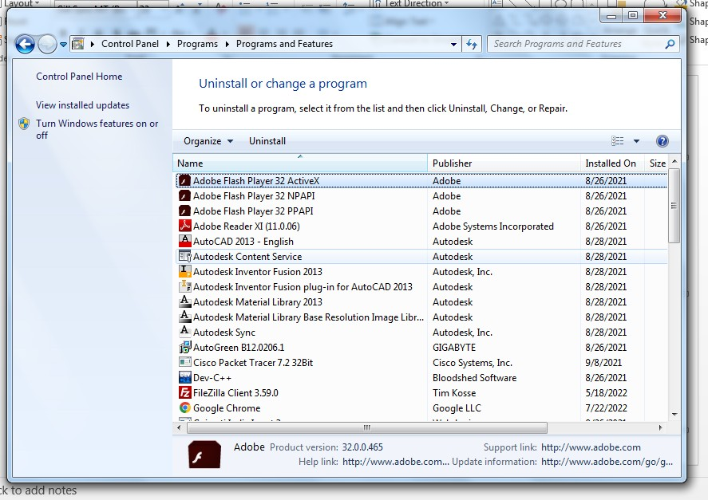



  - Limit the programs at startup
Optimizing the computer performance
  - Not all programs loaded automatically when the system
starts can be found in the Startup folder.
  - You have to access the System Configuration to deactivate these programs.
  - Using the “Run” dialog is the fastest way to access the required list. To open it, press [Win] + [R] and enter “msconfig”.
  - The window that opens contains a tab called “Startup”. It contains a list of all programs that are launched automatically when the system starts.



startup, you can disable the automatic start setting by
Optimizing the computer performance
- Once you find the program you don’t want to run on
unchecking the checkbox.
  - Windows even lets you deactivate all applications at once. However, take care when using this option:
  - Some of the programs may play an important role in keeping your PC functioning properly.
  - The program remains visible in the list after deactivation,
which makes it easy to undo your decision.
  - The programs in the Startup folder should be based on your individual requirements. You can load all the programs you use every time when the system starts. Ex. Antivirus, backup software etc.


Optimizing the computer performance
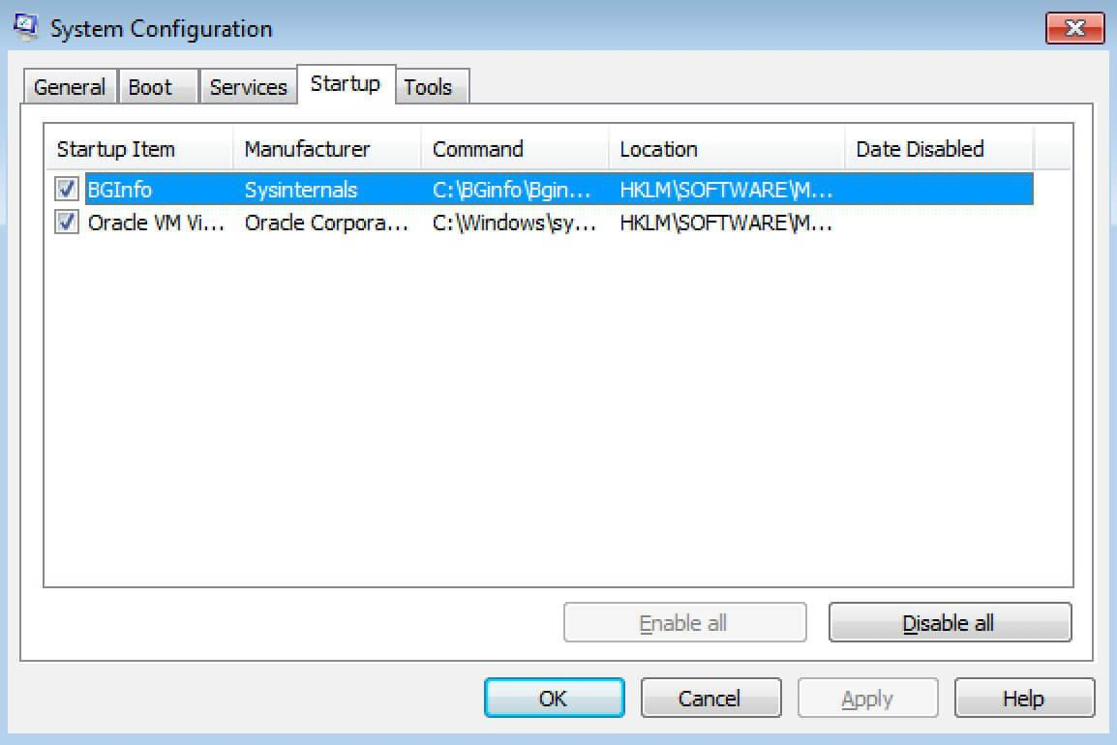



  - Add more RAM to your PC
Optimizing the computer performance
  - This will increase speed of the PC.
  - Check for spyware and viruses
  - use antivirus software.
  - Use Disk Cleanup and defragmentation
  - Disk Cleanup
  - Disk Cleanup is a Microsoft software utility first introduced with Windows 98 and included in all subsequent releases of Windows. It allows users to remove files that are no longer needed or that can be safely deleted.



  - Disk Cleanup
Optimizing the computer performance
  - Removing unnecessary files, including temporary files, helps speed up and improve the performance of the hard drive and computer. Running Disk Cleanup at least once a month is an excellent maintenance task and frequency.
  - Disk Cleanup can delete temporary Internet files, downloaded program files, and offline webpages. Disk Cleanup also allows you to empty the Recycle Bin, delete temporary files, and delete thumbnails.



  - How to open Microsoft Disk Cleanup
Optimizing the computer performance
Windows 10 and Windows 8
- Press Windows key+X to open the Power User Task Menu.
- In the menu, tap or click the Run option.
- In the Run text field, type cleanmgr and press Enter.

Windows 7 and earlier
Open the Start menu.
Click Programs > Accessories > System Tools. In System Tools, click the Disk Cleanup utility.
or
Open the Start menu. Click the Run option.
In the Run text field, type cleanmgr and press



  - Once Disk Cleanup opens, the initial window asks you which drive you want to clean up.
Optimizing the computer performance
  - Select the appropriate drive and click OK.
  - In the next window that opens, check each of the boxes you want to clean up.
  - To the right of each item is the disk drive space each of the items are taking up on the hard drive.
  - Once each of the boxes is checked, click OK to start the cleanup process.



  - What is defragmentation and why do I need it?
Optimizing the computer performance
  - Defragmentation, also known as “defrag” or
“defragging”, is the process of reorganizing the data stored on the hard drive so that related pieces of data are put back together, all lined up in a continuous fashion.
  - You could say that defragmentation is like cleaning house for your Servers or PCs, it picks up all of the pieces of data that are spread across your hard drive and puts them back together again, nice and neat and clean.
  - Defragmentation increases computer performance.



  - How Fragmentation Occurs
Optimizing the computer performance
  - Disk fragmentation occurs when a file is broken up into
pieces to fit on the disk.
  - Because files are constantly being written, deleted and resized, fragmentation is a natural occurrence.
  - When a file is spread out over several locations, it takes longer to read and write resulting in slow computer performance.



  - How to do disk defragmentation
Optimizing the computer performance
- Allow Disk Defragmenter to run automatically
open control panel -> system and security -> administrative tools -> defragment your hard drive -> configure schedule -> then enter day and time and frequency when you want to run defragmentation automatically.



- Manually run Disk Defragmenter
Optimizing the computer performance
  - Click the Start menu or Windows button
  - Select Control Panel, then System and Security
  - Under Administrative Tools, click Defragment your hard drive
  - Select Analyze disk. The report you get will indicate if you need to defrag your disk.
  - If you need to manually defrag your disk, click Defragment disk


Optimizing the computer performance
- Consider a startup SSD
  - When you want better performance, a startup solid-state drive (SSD) can go a long way toward taking some of the pressure off the processor when your computer boots up.
  - If you tend to run a number of applications at one time or use photo and video editing software, then a startup drive can go a long way toward making these programs run smoother and load faster.
  - While they’re most commonly installed on desktop computers, SSDs can be used on some laptop models as well. When you don’t have the option of using an internal SSD, you can always purchase an external drive that connects to your PC with a USB.
  - This drive can give you the extra push you need at startup to accomplish tasks and give you a boost for apps that need more temporary memory to run properly.



  - Take a look at your web browser
Optimizing the computer performance
  - If you have a full cache that has not been emptied in a while, then you’ll want to visit your settings and make sure that it’s empty.
  - Your cache includes what you pick up when you are visiting various websites.
  - Many sites use cookies in order to figure out your browsing habits and the ads you may click when you visit a site will leave one too.
  - A cache holds these files as information and if you spend a lot of time online, these files can accumulate and cause your computer to run more slowly.


Optimizing the computer performance
  - There are two ways to do this in the more popular web browsers:
  - For Internet Explorer:
  - Visit “Internet Options”
  - Click on the “General” tab
  - Look for the “Browsing History” option
  - Select “Temporary Internet Files” and “Website Data”
  - Hit “Delete”
  - For Google Chrome:
  - Visit “More settings”
  - Select “More tools”
  - Click “Clear browsing data”
  - Note that Chrome allows you to delete data within a certain time period
  - If you’ve never deleted the files in your cache before, you’ll want to select “All
time”
  - Check the boxes “Cookies and other site data” and “Cached images and files”
  - Hit “Clear data”

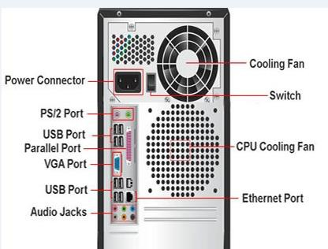

Plug and Play concepts

Types of Computer Ports

  - A computer is a device that transforms data into meaningful
information.
  - It processes the input according to the set of instructions provided to it by the user and gives the desired output.
  - As we know that we can connect multiple external devices with the computer system.
  - Now, these devices are connected with the computer using Ports.
  - The ports are the physical points present in the computer through which the external devices are connected using cables.
  - Or in other words, a port is an interface between the motherboard
and an external device of the computer.

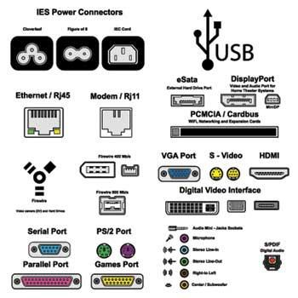
Types of Computer Ports

Types of Computer Ports

Serial port(COM Port):
A serial port is also called a communication port and they are used for connection of external devices like a modem, mouse, or keyboard (basically in older PCs).
It transfers information one bit at a time between the computer and external peripherals.
Serial cables are cheaper to make in comparison to parallel cables and they are easier to shield from interference.
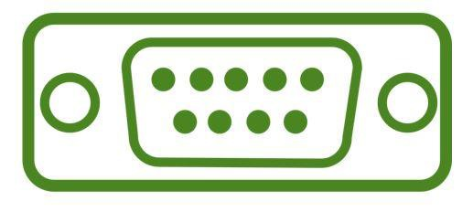
There are two versions of it, which are 9 pin model and 25 pin model. It transmits data at 115 KB/sec.

Types of Computer Ports

Parallel Port (LPT ports):
- Parallel ports are generally used for connecting scanners and printers.
- It can send several bits at the same time as it uses parallel communication.
- Its data transfer speed is much higher in comparison with the serial port.
- It is a 25 pin model. It is also known as Printer Port or Line Printer Port.

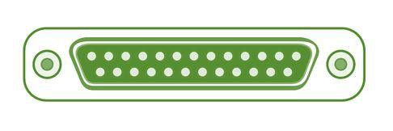

Types of Computer Ports

- USB (Universal Serial Bus):
- In 1997 USB was first introduced.
- This can connect all kinds of external USB devices, like external hard disk, printer, scanner, mouse, keyboard, etc.
- There are minimum of two USB Ports provided in most of the computer systems.
- It is a kind of new type serial connection Port that is much faster than the old serial Ports and These USB Ports are much smarter and more versatile.

- USB ports can be used as a power supply for different devices like cellphones, cameras, laptop coolers and more.

Types of Computer Ports

- PS/2 Port:
- PS/2 ports are special ports used for connecting old computer keyboard and mouse.
- It was invented by IBM.
- In old computers, there are minimum of two PS/2 Ports, each for the keyboard and the mouse. It is a 6 pin mini Din connector.
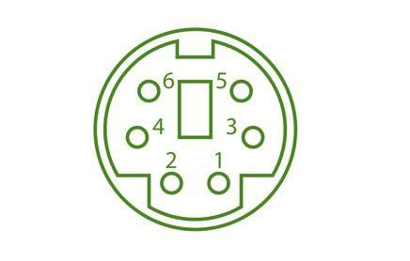

Types of Computer Ports

- VGA Port:
- VGA ports also known as Video Graphic Array connector are those which
connect the monitor to a computer’s video card.
- It is used for connecting the monitor with the video adapter from the computer motherboard to display video on your monitor.
- VGA port has 15 holes and it is similar to the serial port connector. But VGA Ports have holes in it and the serial port connector has pins in it.



Types of Computer Ports

- Sockets:
- Microphones and speakers are connected with the help of Sockets to the sound card of the computer.

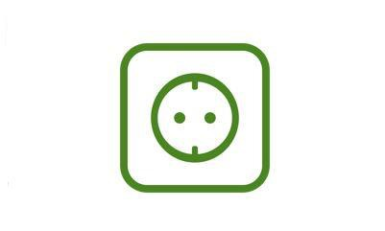

Types of Computer Ports

- Ethernet/Internet Port:
- Ethernet Port helps to connect to a network and high-speed Internet(provided by LAN or other sources).
- It connects the network cable to a computer and resides in a Ethernet card.
- They were first introduced in 1980 to standardize the local area networks (LAN).
- Internet ports use RJ45 connectors and have speeds between 10 Mb/sec –
100 Mb/sec – 1 Gb/sec – 40 Gb/sec – 100 Gb/sec.
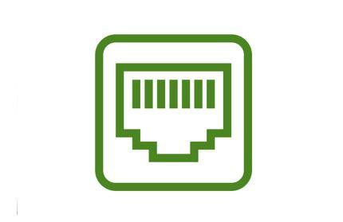
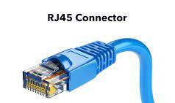
- An RJ45 cable is primarily used to connect devices over an Ethernet. For example, computers, printers, network storage devices etc. , are some devices capable of using an RJ45 connection. Being able to identify an RJ45 cable is important when attempting to connect devices to a network.

Types of Computer Ports

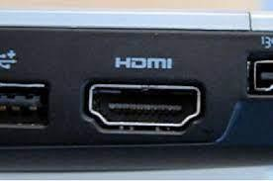
- HDMI (High Definition Multimedia Interface): Ports on computer to transmit High Definition (1080p+) Video from the computer video card to the monitor.

Types of Computer Ports

- Firewire Port
- Transfers large amount of data at very fast speed.
- Data travels at 400 to 800 megabits per seconds.
- Invented by Apple.
- It has three variants: 4-Pin FireWire 400 connector, 6-Pin FireWire 400 connector, and 9-Pin FireWire 800 connector.
- Along with USB, Firewire (also called IEEE 1394) is another popular
connector for adding peripherals to your computer.
- Firewire is most often used to connect digital camcorders, external hard drives, and other devices that can benefit from the high transfer rates (up to 480 Mbps) supported by the Firewire connection.
- Most modern computers don't have FireWire ports built-in. You'd have to upgrade them, which costs extra and may not be possible on every computer. The most recent USB standard is USB4, which supports transfer speeds as high as 40,960 Mbps. It's much faster than the 800 Mbps that FireWire supports.

Types of Computer Ports

- DVI Port (Digital Visual Interface)
- Common devices that utilize the DVI connection are computer monitors and projectors.
- DVI offers a distinctly sharper, better picture than VGA.
- DVI can even be used with some TVs, although HDMI is more common as only some DVI cables can transmit video signals.

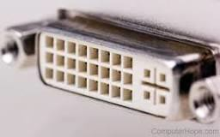



Working with Internet Drive Storage
- Online data storage refers to the practice of storing electronic data with a third-party service accessed via the Internet.
- It is an alternative to traditional local storage (such as disk or tape drives) and portable storage (such as optical media or flash drives).
- It can also be called “hosted storage,” “Internet storage” or “cloud storage.”
- In recent years, the number of vendors offering online data storage
for both consumers and businesses has increased dramatically.
- Some services store only a particular kind of data, such as photos, music or backup data, while others will allow users to store any type of file.
- Most of these vendors offer a small amount of storage for free with additional storage capacity available for a fee, usually paid on a monthly or annual basis.

BENEFITS OF ONLINE STORAGE
- One of the biggest benefits of online storage is the ability to access data from anywhere.
- As the number of devices, the average person uses continues to grow, syncing
or transferring data among devices has become more important.
- Not only does it help transfer data between devices, online data storage also provides the ability to share files among different users.
- This is particularly helpful for business users, although it’s also popular with consumers who want to share photos, videos and similar materials with their friends and family.
- Online data storage also offers distinct advantages for backup and disaster
recovery situations because it’s located off site.
- In a fire, flood, earthquake or similar situation, on-site backups could be damaged, but online backups won’t be affected unless the disaster is very widespread.
- However, online data storage does have some potential downsides.
- Some people worry about the security of cloud storage services, and some vendors have experienced significant outages from time to time, leading to concerns about reliability.

ONLINE STORAGE ENHANCES DATA PROTECTION AND AVAILABILITY
- Before the development of the Internet, computer systems were limited to local storage or portable storage, first in the form of tapes and floppy disks, then CDs, DVDs and USB thumb drives. Generally, using on-site storage is faster than using Internet storage, because you don’t have to wait for files to upload or download.
- However, on-site storage is more susceptible to loss due to theft, natural disasters or device failure.
- By contrast, most online data storage facilities offer enhanced physical security and automated backup capabilities to ensure that data is not lost. Online data storage also enables easier data transfer and sharing.
- Like local storage, portable storage devices offer fast data transfer along with some data transfer and sharing capabilities.
- However, portable storage isn’t quite as convenient as online data storage, particularly if you want to share files with a large number of users. Portable storage devices are also easy to lose or damage, and they offer limited storage capacity.

ONLINE STORAGE ENHANCES DATA PROTECTION AND AVAILABILITY
- Recently, the term cloud storage has become increasingly common.
- Although many people use the terms “cloud storage” and “online storage” interchangeably, technically, cloud storage is a particular kind of online data storage.
- Many individuals and organizations use a mix of on-site and online storage capabilities.
- For example, they might use local storage for files they use frequently and online storage for backup or archive data. Or they might use local storage for personal data and online storage for files that they wish to share with others.
- Examples of online storage include services such as Google
Drive, Dropbox and Apple iCloud.

What is Computer?
- An electronic machine that accepts data, processes it, and produces output.
- Works on IPO Cycle: Input → Process → Output
- Stores data for future use

Applications of Computer

- Education – e-learning, libraries
- Business – accounting, e-commerce
- Healthcare – medical records, imaging
- Communication – email, video conferencing
- Entertainment – gaming, movies, music
- Science & Engineering – simulations, AI
- Government – e-governance, record keeping

Architecture of Computer

  - Input Unit – takes input from user
  - CPU: Control Unit, ALU, Registers
  - Memory Unit – stores data & instructions
  - Output Unit – shows result to user

Basic Components of Computer

- Input Devices – Keyboard, Mouse
- Output Devices – Monitor, Printer
- CPU – Brain of computer
- Memory – RAM, ROM
- Storage – HDD, SSD
- Motherboard – Connects all parts
- Power Supply (SMPS) – Provides electricity

Peripheral Devices

- Input – Keyboard, Mouse, Scanner, Webcam
- Output – Monitor, Printer, Speakers
- Storage – External HDD, Pen drive, CD/DVD
- Communication – Modem, Network Card

Data Storage Devices

- Primary Memory: RAM (volatile), ROM (non- volatile), Cache, Registers
- Secondary Memory: Magnetic (HDD), Optical (CD/DVD), Flash (SSD, USB)

Booting Steps

- Power ON
- POST (Power-On Self-Test)
- BIOS/UEFI loads
- Operating System loads into RAM
- User login screen appears

Motherboard Slots

- CPU Socket – processor
- RAM Slots (DIMM) – memory modules
- PCI/PCIe Slots – graphics/sound/Wi-Fi card
- SATA / M.2 Slots – storage devices
- USB Headers – external connections
- Power Connectors – ATX, CPU

Optimizing Computer Performance

- Use SSD instead of HDD
- Increase RAM
- Clean temporary files & cache
- Use antivirus & firewall
- Keep OS & drivers updated
- Disable unnecessary startup programs

Plug & Play Concept

- Technology that detects and configures hardware automatically
- Examples: USB drives, printers, external HDDs
- Advantage: No manual driver installation needed

